UNIT 2 HW

1. The world’s smallest mammal is the bumblebee bat, also known as the Kitti’s hog nosed bat. Such bats are roughly the size of a large bumblebee! Listed below are weights (in grams) from a sample of these bats. Test the claim that these bats come from the same population having a mean weight equal to 1.8 g.  *(Beware: This data is not the same as in the lecture slides!)*

Sample: 1.7 1.6 1.5 2.0 2.3 1.6 1.6 1.8 1.5 1.7 1.2 1.4 1.6 1.6 1.6

* 1. Perform a complete analysis using SAS. Use the six step hypothesis test with a conclusion that includes a statistical conclusion, a confidence interval and a scope of inference (as best as can be done with the information above … there are many correct answers given the vagueness of the description of the sampling mechanism.)

**Code:**

/*Step 1: Identify the null (H0 and alternative)| h0 = 1.8 ha <> 1.8

*/

/*

Step 2: Draw, Shade, and fine the critical value

*/

data batscv;

alpha = .05;

p = 1-alpha/2;

df = 14;

CritVal = TINV(p, df);

proc print data = batscv;

run;

;

/*

* Step 3-5: Find the test statistic

*/

proc ttest data = bats alpha = .05 h0= 1.8 sides = 2 alpha = .05;

var batkg;

run;

**Step 1: Identify the null (H0 and alternative)**

**H0 = 1.8**

**Ha <> 1.8**

**Step 2: Draw, Shade, and fine the critical value**



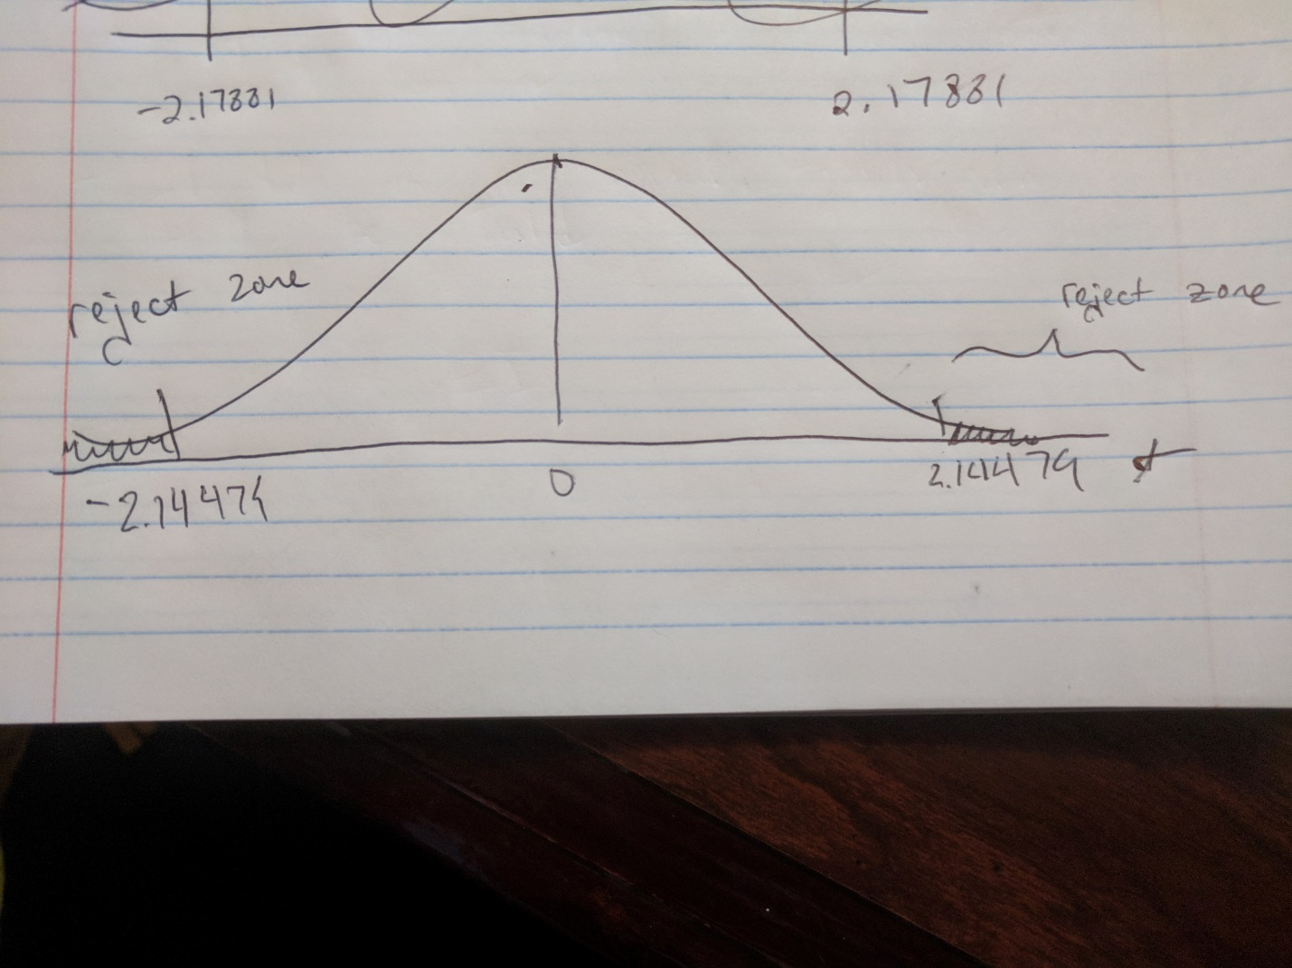

**Step 3:**

**Find the test statistic (in yellow): -2.35**

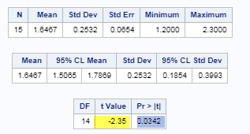

**Step 4**

**Find the p value (highlighted in blue): .0342**



**Step 5 Reject H0 or Accept Ha**

**Rejecting H0**

**Step 6:**

**We have a population of bats with a population mean of 1.8. A sample of bats were provided without a description of the sampling mechanism and data is provided. There is sufficient evidence that that we can reject the null hypothesis with a p value of .0342 and a 95% confidence interval for this difference is (1.5065,1.7869). However, since it is vague as to how the randomization occurred, we can only infer that these results are generalized to the 15 bats.**

* 1. Inspect and run this R Code and compare the results (t statistic, p-value and confidence interval) to those you found in SAS. To run the code, simply copy and paste the below code into R.

***sample = c(1.7, 1.6, 1.5, 2.0, 2.3, 1.6, 1.6, 1.8, 1.5, 1.7, 1.2, 1.4, 1.6, 1.6, 1.6)***

***t.test(x=sample, mu = 1.8, conf.int = "TRUE", alternative = "two.sided" )***

One Sample t-test

data: sample

t = -2.3457, df = 14, p-value = 0.03424

alternative hypothesis: true mean is not equal to 1.8

95 percent confidence interval:

1.506466 1.786868

sample estimates:

mean of x

1.646667

**The results are the same, but SAS seems to be rounded and R has more significant digits.**

1. In the United States, it is illegal to discriminate against people based on various attributes. One example is age. An active lawsuit, filed August 30, 2011, in the Los Angeles District Office is a case against the American Samoa Government for systematic age discrimination by preferentially firing older workers. Though the data and details are currently sealed, suppose that a random sample of the ages of fired and not fired people in the American Samoa Government are listed below:

**Fired**

34 37 37 38 41 42 43 44 44 45 45 45 46 48 49 53 53 54 54 55 56

**Not fired**

27 33 36 37 38 38 39 42 42 43 43 44 44 44 45 45 45 45 46 46 47 47 48 48 49 49 51 51 52 54

* + - * 1. Perform a permutation test to test the claim that there is age discrimination. Provide the Ho and Ha, the p-value, and full statistical conclusion, including the scope. Note: this was an example in Live Session 1. You may start from scratch or use the sample code and PowerPoints from Live Session 1.

H0 = Average Fired Age = Average Not Fired Age | uF – uNF = 0

HA = Average Fired Age <> Average Not Fired Age | uF – uNF <> 0

p-value = .5282

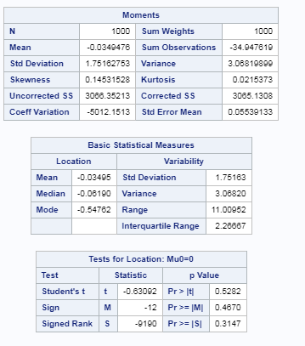

**There is not sufficient evident to suggest that the mean age of those who were fired is different than the mean age of those who were not fired. P-value of .5282. The p-value is so high that even the null hypothesis of a one-sided test cannot be rejected. Since this was a random sample of government employees in Samoa, we can only generalize this inference to all government-employed people in Samoa.**

* + - * 1. Now run a two sample t-test appropriate for this scientific problem. (Use SAS.) *(Note: we may not have talked much about a two-sided versus a one-sided test. If you would like to read the discussion on pg. 44 (Statistical Sleuth), you can run a one-sided test if it seems appropriate. Otherwise, just run a two-sided test as in class. There are also examples in the Statistics Bridge Course).* Be sure to include all six steps, a statistical conclusion and scope of inference.

Step 1: Identify the H0 and Ha

H0 = Average Fired Age = Average Not Fired Age | uF – uNF = 0

HA = Average Fired Age <> Average Not Fired Age | uF – uNF <> 0

Step 2:

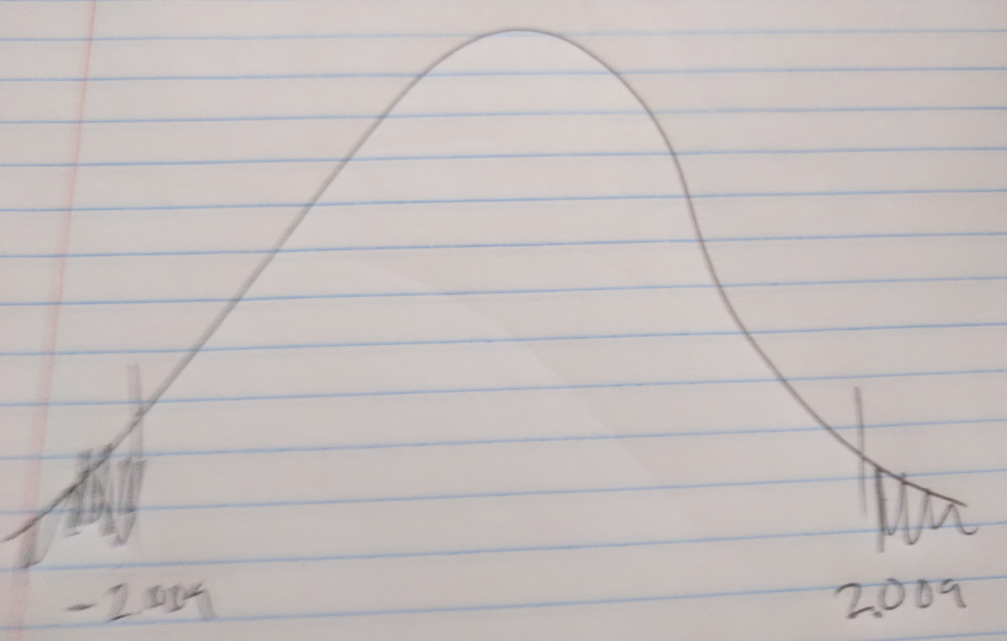

*Critical value: 2.009*

*Step 3:*

*Find the t-value: -1.10*

*Step 4:*

*Find the p-value: .2771*



*Step 5:*

*Fail to reject H0*

*Step 6:*

*There is not sufficient evidence to suggest that the mean age of those who were fired is different from the mean age of those who were not fired (p-value = 0.2771).*

* + - * 1. Compare the two pvalues generated in a and b.



*.2771 vs .5282*

*Both are high p-values that both failed to reject the null hypothesis.*

* + - * 1. The jury wants to see a range of plausible values for the difference in means between the fired and not fired groups. Provide them with a confidence interval for the difference of means and an interpretation.

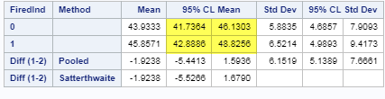

***Highlighted above showing confidence intervals for the individuals that were not fired with a 95% confidence interval of (41.47364, 46.1303). Also, for the group that was fired, we have a 95% confidence interval of (42.8886, 48.8256). We can see that these two intervals overlap and that the means of the two groups have a good chance of being within both the confidence intervals meaning there is a chance that these means can equal each other. This further helps to fail to reject the null hypothesis.***

* + - * 1. Given the sample standard deviations from SAS, calculate by hand

Pooled standard deviation (sp)

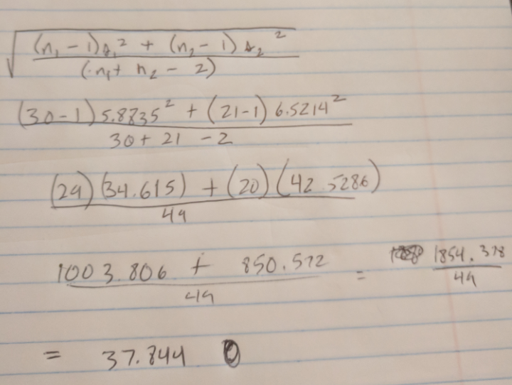

The standard error of ()

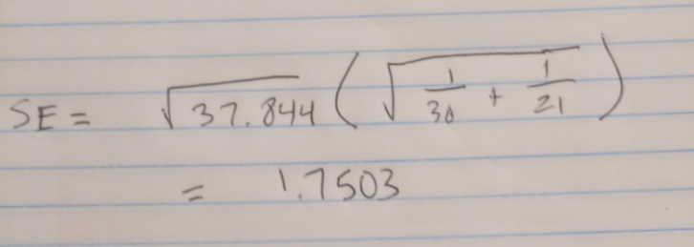

* + - * 1. Inspect and run this R Code and compare the results (t statistic, p-value, and confidence interval) to those you found in SAS. To run the code, simply copy and paste the code below into R.

***Fired = c(34, 37, 37, 38, 41, 42, 43, 44, 44, 45, 45, 45, 46, 48, 49, 53, 53, 54, 54, 55, 56)***

***Not_fired = c(27, 33, 36, 37, 38, 38, 39, 42, 42, 43, 43, 44, 44, 44, 45, 45, 45, 45, 46, 46, 47, 47, 48, 48, 49, 49, 51, 51, 52, 54)***

***t.test(x = Fired, y = Not_fired, conf.int = .95, var.equal = TRUE, alternative = "two.sided")***

***Output:***

data: Fired and Not_fired

t = 1.0991, df = 49, p-value = 0.2771

alternative hypothesis: true difference in means is not equal to 0

95 percent confidence interval:

-1.593635 5.441254

sample estimates:

mean of x mean of y

45.85714 43.93333

**The t-statistic is positive in R (1.0991) and negative in SAS (-1.10).**

**DF is the same at 49**

**p-value is the same at .2771. The 95% confidence interval is way different in R compared to SAS at (-1.593635, 5441254). This is strange and in this case, with the means and the confidence interval, we would reject the null hypothesis.**

1. In the last homework, it was mentioned that a Business Stats professor here at SMU polled his class and asked students them how much money (cash) they had in their pockets at that very moment. The idea was that we wanted to see if there was evidence that those in charge of the vending machines should include the expensive bill / coin acceptor or if it should just have the credit card reader. However, another professor from Seattle University was asked to poll her class with the same question. Below are the results of our polls.

**SMU**

34, 1200, 23, 50, 60, 50, 0, 0, 30, 89, 0, 300, 400, 20, 10, 0

**Seattle U**

20, 10, 5, 0, 30, 50, 0, 100, 110, 0, 40, 10, 3, 0

* + - * 1. Run a two sample t-test to test if the mean amount of pocket cash from students at SMU is different than that of students from Seattle University. Write up a complete analysis: all 6 steps including a statistical conclusion and scope of inference (similar to the one from the PowerPoint). (This should include identifying the Ho and Ha as well as the p-value.) Also include the appropriate confidence interval. **FUTURE DATA SCIENTIST’S CHOICE!: YOU MAY USE SAS *OR* R TO DO THIS PROBLEM!**

Step 1:

H0 = uSMU = uSeattleU | uSMU – uSeattleU = 0

HA = uSMU<> uSeattleU

Step 2:

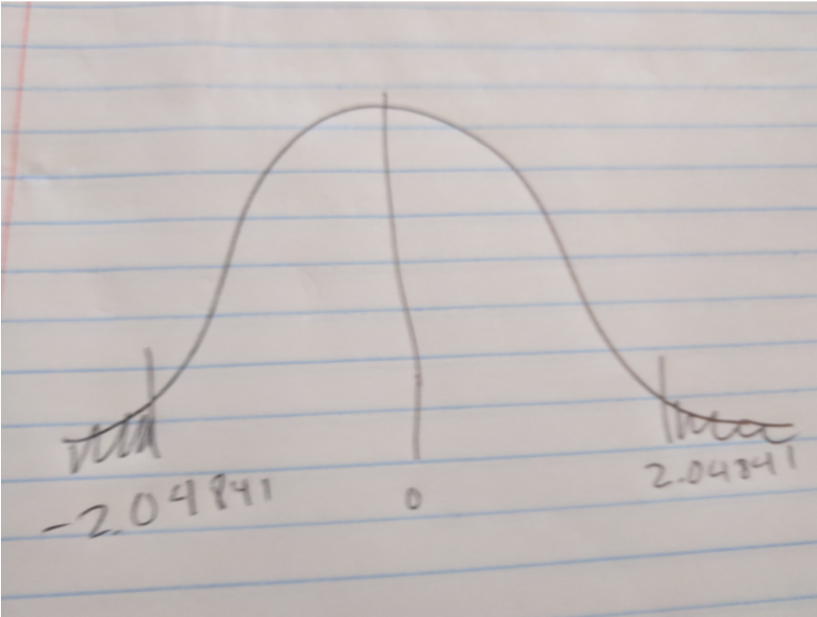

Step 3:

t-value = 1.40

Step 4: P-Value = .1732

Step 5:

Fail to reject the null hypothesis

Step 6:

There is not sufficient evidence to suggest that the mean dollars of those from SMU are different than the mean dollars from SeattleU. The p-value is high at .1732 and the two-side test cannot be rejected.

* + - * 1. Compare the p-value from this test with the one you found from the permutation test from last week. Provide a short 2 to 3 sentence discussion on your thoughts as to why they are the same or different.

P-value from last week: .1074

P-value today: .1732

P-values are pretty close and we still fail to reject the null hypothesis.

1. A. Calculate the estimate of the pooled standard deviation from the Samoan discrimination problem. Use this estimate to build a power curve. Assume we would like to be able to detect effect sizes between 0.5 and 2 and we would like to calculate the sample size required to have a test that has a power of .8. Simply cut and paste your power curve and SAS code. HINT: USE THE CODE FROM DR. McGEE’s lecture. Instead of using **groupstddevs**, use **stddev** since we are using the pooled estimate.

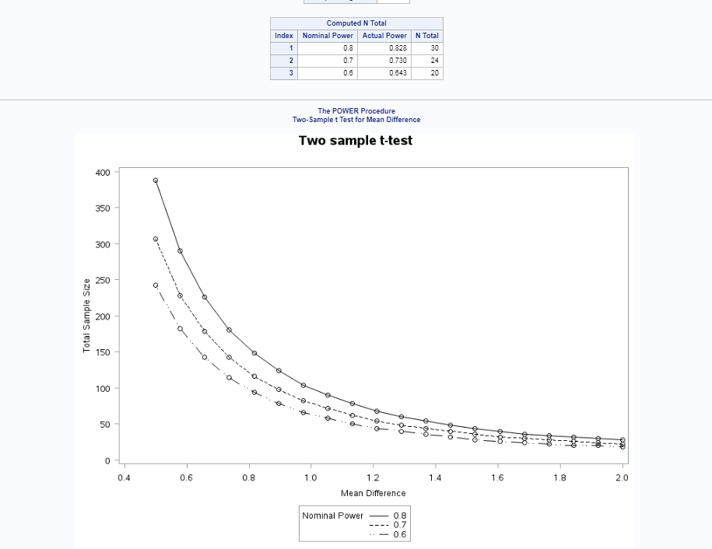

proc power;

twosamplemeans

meandiff= -1.9238

stddev = 1.75

power = .8 .7 .6

ntotal = .;

PLOT X = effect Min =.5 Max = 2;

run;

B. Now suppose we decided that we may be able to live with slightly less power if it means savings in sample size. Provide the same plot as above but this time calculate curves of sample size (y-axis) vs. effect size (.5 to 2) (x axis) for power = 0.8, 0.7, and 0.6. There should be three plots on your final plot. Simply cut and paste your power curve and SAS code. HINT: USE THE CODE FROM DR. McGEE’s lecture. Instead of using **groupstddevs**, use **stddev** since we are using the pooled estimate.

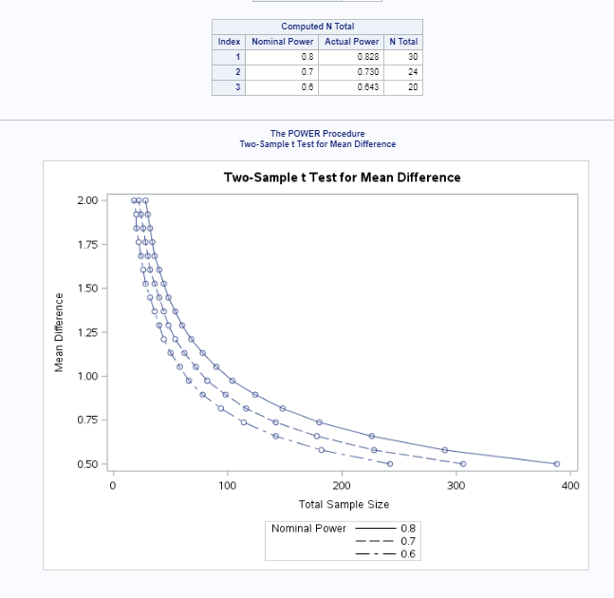

proc power;

twosamplemeans

meandiff= -1.9238

stddev = 1.75

power = .8 .7 .6

ntotal = .;

PLOT y = effect Min =.5 Max = 2;

run;

**x default is power.**

C. Using similar code, estimate the savings in sample size from a test aimed at detecting an effect size of 0.8 with a power of 80% versus a power of 60%.

Note: You will learn how to do this in R in a future HW!

.

Savings of 10.

8:

